Comparative Study of Classifiers on Human Activity Recognition Based on Feature Importance

Mahbuba Tasmin, Taoseef Ishtiak, Sharif Uddin Ruman, Arif-Ur Rahman Chowdhury Suhan , N.M. Shihab Islam, Sifat Jahan
Sajid Ahmed, Md. Shahnawaz Zulminan, Abdur Raufus Saleheen, Rashedur M. Rahman
Department of Electrical & Computer Engineering, North South University
Plot-15, Block-B, Bashundhara, Dhaka 1229, Bangladesh
mahbuba.tasmin@northsouth.edu, taoseef.ishtiak@northsouth.edu, sharif.ruman@northsouth.edu, arif.suhan@northsouth.edu, shihab.islam@northsouth.edu, sifat.jahan@northsouth.edu, sajid.ahmed1@northsouth.edu, shahnawaz.zulminan@northsouth.edu, abdurraufus.saleheen@northsouth.edu, rashedur.rahman@northsouth.edu

Abstract— This paper presents a comparative discussion of classification approaches for human activity recognition tasks based on the feature sets through extensive feature selection works. The original dataset Human Activity Recognition from Continuous Ambient Sensor Dataset is collected from UCI machine learning repository and five specific activities (Watching TV, Reading, Talking over Phone, Cooking and Eating) have been selected from there for the purpose of this research. The scraped feature set is run through four feature selection methods based on statistical significance of features and node impurity and four different feature sets are produced from this step. Later on, Principal Component Analysis is applied on the four feature sets to reduce feature space and five principal components are selected to cover more than 90% data variance of the feature sets. And then, performance of five classifier models (K Nearest Neighbors, Decision Tree, Random Forest, Gaussian Naïve Bayes and MLP classifier using Backpropagation) is evaluated against the five feature sets (including the scraped dataset without feature selection). The selection of feature set based on different approaches of feature importance creates a computational complexity and difference in outputs for each feature set on each classifiers. The result shows that Multi-layer Perceptron using Backpropagation algorithm achieves better accuracy on human activity recognition on the five feature sets. The research finding highlights the necessity of data preprocessing and significant feature selection for getting better accuracy score for noisy time-series data of HAR activity)
Keywords- Human Activity Recognition, Time Series Data, Activity Classification, Feature Engineering, Sensor

Introduction
The advancement of Internet of Things (IoT) has paved the way for smart living in home spaces using intelligent system installed in the framework of home [1]. Smart intelligent appliances have been developed for convenient living style, which is gradually proceeding towards assisted living through interacting system space. Ambient Assisted Living [2] emerged with the aim of easing the life in indoor space for the independent elderly citizens, through the use of smart technology in home. AAL focuses on health care monitoring and user interaction [3], which requires the necessity of human activity recognition from Activities of Daily Life (ADL). Better performance of an AAL system installed in a home depends on the accuracy of the system to interact with user and to diagnose the activities to take actions accordingly. AAL infrastructures highly depend on wireless sensor networks [5] placed at home to collect stream of sensor data of human activities in the surrounding. In general, activity recognition is a context-aware system [6, 7], aimed to sense the surrounding activities and execute the system features consequently.
Sensor data for human activity recognition works are collected from wearable devices, smartphones and indoor infrastructure of wireless sensors [8]. The sequential or time-series datasets collected from the above mentioned systems are complex [9, 10] in terms of interpretation with comparison to computer vision based activity recognition. Time-series data for human activity recognition is checked for detecting change detection [11] or activity transition through calculating statistical metrics (e.g. Mean and Covariance). Robust activity learning technology is required in the IOT environment to provide proper services to its residents. By providing the information about activity transitions and insights on activity start/end times and durations, activity segmentation improves the robustness of these technologies. The beginning and ending point of each activity is known when recognizing activities from a pre-segmented data [12].
The image/video datasets of human activity are easier to label and preparation of the dataset. Whereas the sensor collected raw dataset requires intensive feature engineering [13, 14] to achieve an optimum-cost computational algorithm with highest accuracy. The datasets are usually large and requires significant feature selection [15] to discard insignificant attributes and instances and produce a concentrated important feature set. The feature selection approaches are based on statistical scoring on a threshold and node impurity calculation through GINI index. The common approaches include decision tree implementation for scoring of features and forest based categorization of features. Feature space reduction concentrates the dataset in execution reducing the dimension of dataset. It reduces the memory requirements and decreases computational complexity. Feature engineering of time-series data collected from sensors [16] is a necessity to achieve better recognition output through any advanced machine learning model.
This research work is motivated to classify five distinct activities (Watching TV, Reading, Taking on Phone, Cooking, and Eating) from the dataset of 12 pre-defined activities including unlabeled activity namely “other activity”. The dataset has been acquired from the UCI Machine Learning Repository dataset “Human Activity Recognition from Continuous Ambient Sensor Data Dataset” from Washington State University [11]. The motivation is to precisely classify the activities while reducing the number of parameters and selecting important features from original dataset based on statistical approach. This originates from the idea to allow human activity recognition with a minimalist model for saving computation power so that real-life applications upon such model will be lighter. The sensors’ signals is preprocessed in original dataset, among those, features with statistically significant values have been selected for training, feature set space has been reduced for less computational load and finally five different classifier models have been employed to evaluate activity recognition accuracy and a comparative study of performance is reported towards the end. The key finding of this research focuses on the significance of feature engineering for improving human activity recognition accuracy on different feature sets. The results show variance in accuracy depending on the four feature sets through five classifier models.
The major contributions of the proposed research are:
1. Feature Selection: Meaningful feature selection from the five-activity dataset through four feature selection approaches based on statistical significance score.
2. Feature Set Generation: Four Feature sets generation from the statistically significant features from the feature selection step
3. Dimensionality Reduction: Feature sets space reduction through Principal Component Analysis (Five PCs) to prepare for the classifier computation
4. Classifier Performance: Five Classifier models are evaluated on the five feature sets and compared for accuracy on activity recognition.
The rest of the paper is organized as follows. Section II presents the related works on human activity recognition. Section III presents data source and Section IV presents methodology where data preprocessing, feature selection approaches, and classifier models are discussed. Section V reports performance evaluation of the five classifier models on the feature sets. In the following Section VI concludes the paper and gives direction of future works.

RElated work
The research field of activity recognition considers the combination of embedded sensors, different environmental setups and algorithms to detect activity points. Probabilistic graph based Markov models, conditional random fields, Bayesian network [16] are some of the state-of-the-art classification models for detecting activity from times-series data.
Distinct activities like Walking, Running, Standing, Sitting, Climbing Stairs and Falling) are classified in [17] using accelerometer placed on the body. Recently smartphones with embedded motion detector and orientation sensors (Accelerometer and Gyroscope) are used as wearable device to recognize gesture and motion patterns [18]. Improvement in performance, increased accuracy and better results can be attained by the Deep Learning based approaches from raw sensor inputs.
In indoor HAR system, large range of activity are observed through embedded sensors at key location of activities. Environment sensors such as motion detector, light sensor, temperature and pressure sensors etc. are used to record stream of sensor data of activities in [11].
In realistic activity recognition tasks, the recognizing activities are performed with interleaved activities, embedded errors and concurrent activities are performed by multiple individuals in the setup [19]. Detecting activities in free movement setup, where the residents perform usual daily routines in a smart home environment [20]. These recorded datasets requires manual labelling to segment and analyze the data.
Dedicated HAR architectures recognizes sequential and concurrent human activities using multiple sensor data at a time. Two key approaches are followed in HAR: “Data-Driven” and “Knowledge-Driven” technique [22]. Naïve Bayes (NB) classifiers, Decision Trees, Hidden Markov Models, Bayesian Networks and Support Vector Machine (SVM) classifier had been used as the Data-driven method in [22]. Existing works performed with data-driven technique utilize supervised approach using manually labeled data for training. The unsupervised approaches achieve low performance in comparison with the supervised approach in indoor home environment. Activities are classified with the prior knowledge of pre-recorded data of surrounding. Data-driven techniques are useful for detecting basic distinctive activities, on the other hand unsupervised approach is suitable for creating probabilistic models with good accuracy

Data Source
The primary dataset of the project has been collected from UCI Machine Learning Repository [11], Human Activity Recognition from Continuous Ambient Sensor Dataset, published on September 20, 2019. This dataset recorded multiple sensor data placed at volunteer resident houses where the residents performed their daily activities with no direct contact with the data collector infrastructure. Ambient PIR motion sensors, door/temperature sensors, and Light Switch sensors are used to record activity data as event stream the sensors are located in different corners of resident houses to record event data.
Table 1: Key features of the Scraped Dataset
Data Set Characteristics | Multivariate, Sequential, Time Series | Number of Instances | 4475631
Attribute Characteristics | Integer, Real | Number of Attributes | 37
Associated Tasks | Feature Engineering, Classification | Missing Values | Yes
The original dataset is built under the lead of Diane J. Cook from School of Electrical Engineering and Computer Science at Washington State University, and the other creators are Aaron S. Crandall, and Brian L. Thomas. [10]. Figure 1 shows the layout of sensor placement in the indoor environment for data collection in their proposed system.
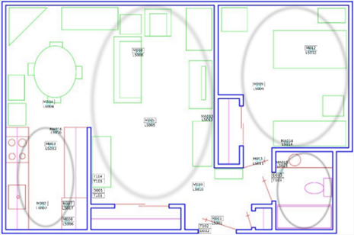
Figure 1: Sensor Layout of One of the Volunteer Resident House

Methodology
This research work focuses on the comparative performance evaluation of the five classifier models on the generated feature sets through extensive feature engineering from the scraped dataset of five activities from “Human Activity Recognition from Continuous Ambient Sensor Data Dataset” [11].The research team has scraped the dataset for this research from the UCI dataset, for the five selected activities (Watching TV, Reading, Talking over Phone, Cooking, and Eating). The attributes of the selected feature set are presented in table 1. The proposed work is primarily divided into three major segments- Feature Engineering, Feature Sets Generation and Performance Evaluation of Classifier models. Figure 2 presents the basic workflow of this project.
A. Feature Engineering
The research team has selected five distinct activities for fitting into a classification model. Statistical significance score of the attributes has been computed to reduce the number of features that do not contribute to training. Four approaches have been considered in feature selection and feature importance paradigm. All the approaches are run on scikit-learn [21].
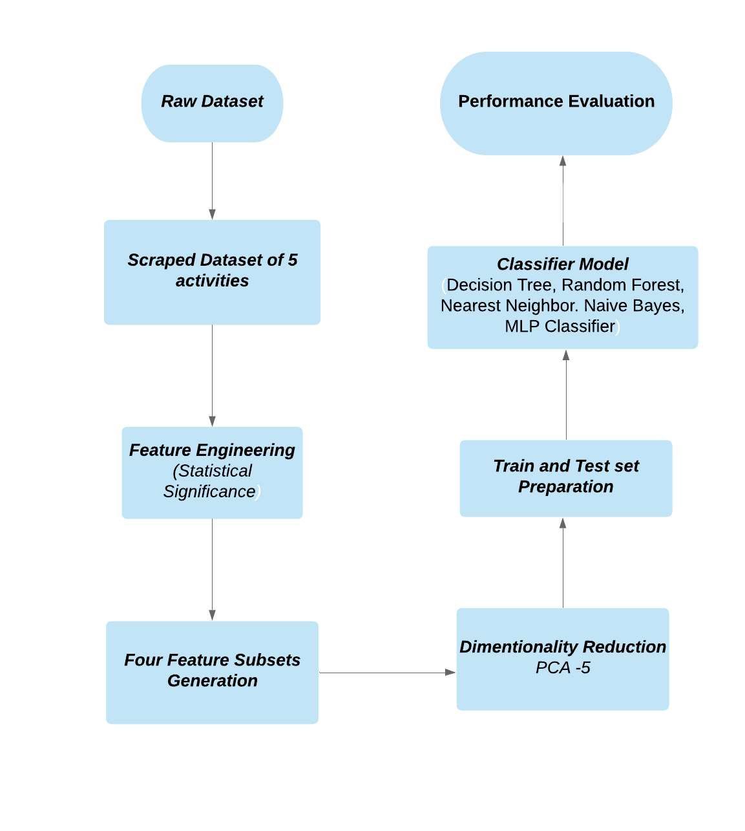
Figure 2: Workflow of the proposed approach
Feature selection approach not only reduces the training time and computational cost but also reduces the variance of the model to avoid overfitting. This section describes the feature selection techniques applied in the proposed research. Table 2 lists the set of significant column attributes found by the four feature engineering approaches. The selected features through different approaches will be used to train a corresponding model.
1) Tree-based Feature Selection:
The tree-based estimators are used to calculate the statistical significance of features and to discard the irrelevant features [24]. Node impurities measure the importance of features in decision trees.
2) Feature Selection with Random Forest:
Random forest classifier uses the tree-based strategies [25] to rank the features for improving purity of the node. The interpretability of this approach is very efficient to derive the importance of each attribute in the dataset based on the tree decision. Feature selection is done by embedded methods in this approach. Such embedded methods are scalable across any dataset for their high accuracy, better generalization and efficient interpretability; including built-in functions for feature selection. Random forest executes a random number of feature selection against each tree. To make the approach less likely to overfit, the trees’ chances of correlation gets decreased as every tree does not observe every variable of the whole dataset [random forest paper]. Impurity measure is executed through information gain or entropy in this approach. The whole model observes how much impurity is dependent upon removing a feature. Across each tree the average impurity decrease determines the final importance of the variable.
Feature importance calculates the score for each feature in a dataset through the implementation of forests of tree-based approach. The Extra Tree classifier and Random Forest classifier have extracted the top important features of the research dataset. Figure 6 presents the feature importance of the forest, along with inter-trees variability. From the achieved importance score, till top 21 features have been considered to train the classifier models.

Table 2: Selected Feature Sets through different Feature Selection Approach

Original Set of Features | Model Obtained Selected Features with Tree-based Feature Selection | Model Obtained Selected Features with Random Forest Classifier | Top 21 Extracted Features by Extra Tree Classifiers | Top 21 Extracted Features by Random Forest Classifier
lastSensorEventHours | √ | √ | √ | √
lastSensorEventSeconds | √ | √ | √ | √
lastSensorDayOfWeek | √ |  | √ | √
windowDuration |  | √ | √ | √
timeSinceLastSensorEvent
prevDominantSensor1 | √ |  | √
prevDominantSensor2 |  |  | √
lastSensorID |  |  | √ | √
lastSensorLocation | √ |  | √ | √
lastMotionLocation | √ | √ | √ | √
complexity |  |  | √ | √
activityChange
areaTransitions |  |  |  | √
numDistinctSensors
sensorCount-Bathroom
sensorCount-Bedroom |  |  | √ | √
sensorCount-Chair
sensorCount-DiningRoom
sensorCount-Hall
sensorCount-Ignore |  |  | √ | √
sensorCount-Kitchen | √ | √ | √ | √
sensorCount-LivingRoom | √ |  | √ | √
sensorCount-Office |  | √
sensorCount-OutsideDoor
sensorCount-WorkArea
sensorElTime-Bathroom |  |  | √ | √
sensorElTime-Bedroom |  |  | √ | √
sensorElTime-Chair |  |  | √ | √
sensorElTime-DiningRoom |  |  | √ | √
sensorElTime-Hall
sensorElTime-Ignore
sensorElTime-Kitchen |  |  | √ | √
sensorElTime-LivingRoom |  |  |  | √
sensorElTime-Office
sensorElTime-OutsideDoor |  |  | √ | √
sensorElTime-WorkArea |  |  | √ | √

The research team has applied this approach upon 37 original attributes of the scraped dataset. Figure 3 & 4 presents the significant features with bar charts. These significant features along with the features stated in Table 2 have also been considered for the final training of the classifiers. The four different approaches of feature selection and feature importance implemented by the research team has given four feature sets against each technique. A comparative analysis has been run at the end of this paper to find the most efficient feature extraction technique for the dataset. Table 2 shows the feature sets against each tree-based feature selection and feature importance approaches

Extra Tree Classifier

The ensemble learning approach of Extremely Randomized Trees Classifiers [26] performs the aggregation of de-correlated decision trees’ results in a forest for classification. The decision trees construction differs in this aspect comparing to the construction of Random Forest Classifier [extra tree classifier paper citation]. Each tree in the forest gets a random K sample of feature-set. Each decision tree selects the best feature to split the data on mathemtical basis cacluated by the Gini Index [28]. The multiple sampling of features aggreagates the multiple de-correlated decision trees. Extra tree classifier performs feature selection in descending order based on the Gini importance with respect to each feature. The research team in this approch has selected the top 21 features in this aspect based on the feature importance score.

Based on the infromation gain the entropy of the data needs to be calculated. The formula for entropy calculation is:-
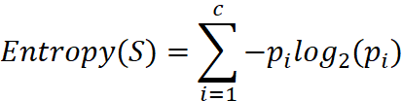
Here, c represents the unique class labels and p_{i} is the rows vs. output label proportion. Again, each tree’s information gain is measure with the formula:-
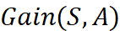 =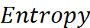 - 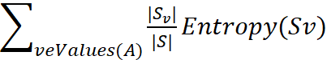
The scikit learn: Extra Tree Classifier makes this calculation easy. Based on the acquired result, top 21 values have been considered for training in next stage and the rest of the features have been neglected for low feature importance score.

Random Forest Classifier

The “random forest” concept brought in this classifier works with several decision trees [27]. Every node in the tree splits the dataset in to sub-set conditioning a single feature. It ensures the similar response values come to the same set. Impurity, here chooses the locally optimal condition by Gini impurity [28] or by the information gain or entropy [information gain/entropy paper]. While training, thus, the computation of decrease in weighted impurity is measured. The average impurity decrease is measured with this approach and the features’ importance are ranked thereby.

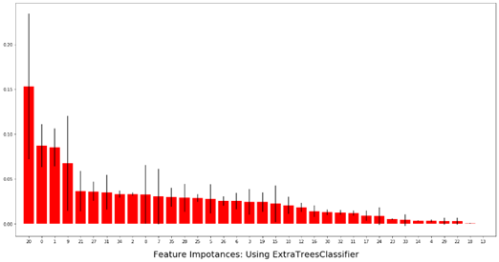
Figure 3: Extra Tree Classifier based feature selection results: Importance Score
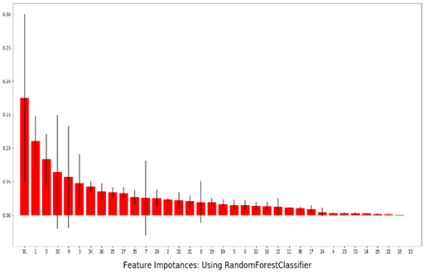
Figure 4: Random Forest Classifier based feature selection results: Importance Score

Feature Set Generation

After the feature engineering is completed, at this step the dimensionality reduction is introduced to reduce the feature space. This is executed to fasten the computation and reduce the memory load of the thousands of instances of the feature sets from feature selection.
This step of the methodology used Principal Component Analysis to reduce the dimension. Considering PC-5, 91% data variance has been covered and it is tested against K Nearest Neighbors ground truth variance value. We have considered five principal components in consideration to the five different feature sets with varied number of attributes. Figure 5 presents the variance range covered by PCA on one of the feature sets (the set without feature engineering). The algorithm tests the data variance by PCA-5 against KNN with nearest neighbors = 3, as a ground truth label.

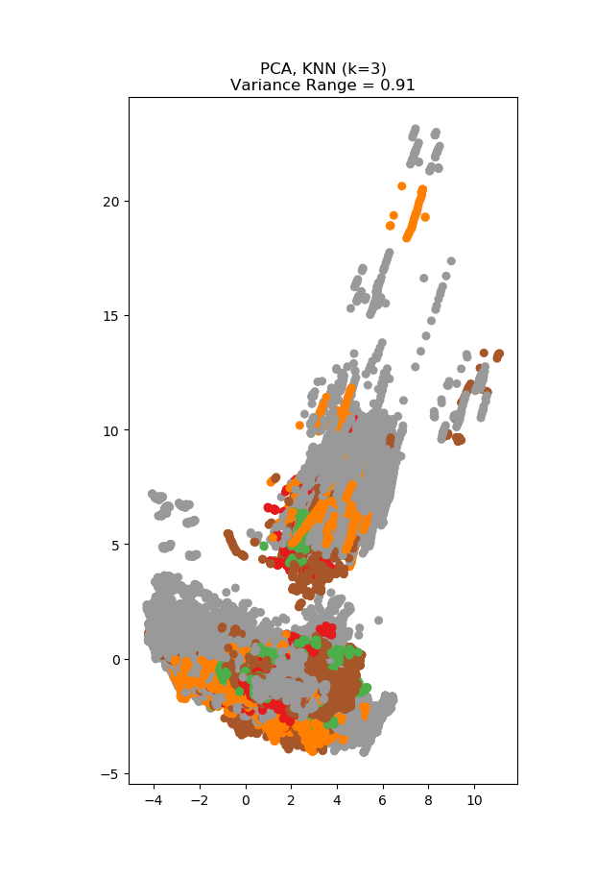
Figure 5: 91% variance achieved by PCA -5 in feature set

Classifier Models
Five classifier models have been evaluated against the five feature sets (Four feature sets through feature engineering and one original feature sets). The variance of the classifiers against the variant feature sets shows the significance of feature engineering and a good classification model for achieving higher accuracy on human activity recognition. The models are - K Nearest Neighbors, Decision Tree, Random Forest, Gaussian Naïve Bayes and MLP classifier using Backpropagation. The feed forward neural network of MLP Classifier achieves the highest accuracy in all the feature sets. All of the models are based on scikit-learn [23]

K Nearest Neighbors

KNN works on the principle of least distance between similar objects, whereby it assumes that similar classes/features stay nearer. The algorithm predicts on the majority support of nearest neighbors of each point.

Decision Tree
Decision tree is a supervised decision support structure consisting of nodes and leaf. The root to leaf path represents the classification rules. The leaves present the labels, internal nodes are features and branches present the outcome of the test.

Random Forest
Random forest approach is an ensemble method of decision trees. It fits decision trees on random sub-sampled dataset and uses averaging from prediction of all the trees to improve the prediction score.

Gaussian Naïve Bayes
This classifier is the Gaussian distribution implementation of Naïve Bayes approach. The supervised approach apply Bayes’ theorem with the “naïve” assumption of pairwise independence of features. It calculates the probability of an instance belonging to a certain class through mean and standard deviation calculation.

MLP Classifier using Backpropagation
Multi-Layer Perceptron or Feed Forward Neural Network is one of the basic deep learning models. This supervised learning model follows repeated execution of forward pass and backward pass. In the forward pass, the signal traverses through the input and hidden layers to the output layer. Output findings are evaluated against the ground-truth labels to calculate the loss function. In the backward pass, the error term is back propagated and weights are updated through gradient calculation until convergence state is reached.

Performance Evaluation
In this section, the accuracy of the five classifier models on the five feature sets are evaluated and compared against each other. The best model output is presented with evaluation metric scores.

Accuracy Comparison of Classifier Models

In the Table 3, the accuracy score on classifying the five selected activities on the five different datasets through the five classifier model is presented. All the feature sets are run through PCA-5 analysis before classifier is applied.

Table 3: Comparison of Accuracy Scores of Classifiers on Feature sets
Classifier | Original Set of Features | Model Obtained Selected Features with Tree-based Feature Selection | Model Obtained Selected Features with Random Forest Classifier | Top 21 Extracted Features by Extra Tree Classifier | Top 21 Extracted Features by Random Forest Classifier
Nearest Neighbors | 74.2 | 75.4 | 72.9 | 75.7 | 75.3
Decision Tree | 75.3 | 76.9 | 75.9 | 76.3 | 75.5
Random Forest | 74.4 | 76.4 | 75.7 | 75.9 | 74.5
Naive Bayes | 74.9 | 76.5 | 76.4 | 76.9 | 76.3
Neural Net | 76.7 | 78.3 | 77.3 | 78.5 | 78.1

Here, the Extra Tree Classifier feature set shows the highest accuracy on average for all the classifier models. Among the five classifiers, Feed forward Neural Network performs the best. In figure 6, a bar chart is shown to present the accuracy score on the feature set of Extra Tree Classifier.

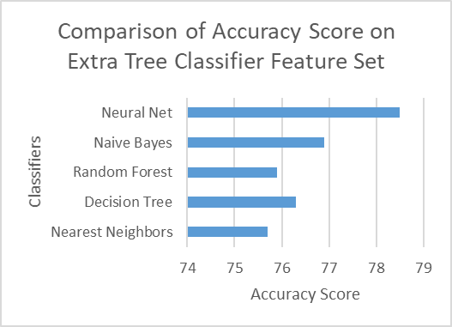

Figure 6: Comparison of Accuracy Score on Extra Tree Classifier Feature Set

Evaluation Metric Calculation

The performance of the three classifier model on 3 datasets is evaluated through four key metrics of accuracy: precision, recall, f1-score and support. The confusion matrix and evaluation metrics are presented here on the basis of the different datasets and the result of classification models on those datasets. The activities are coded into numerical values in here, hence the below graphs will show activity id comparisons.

Accuracy gives the sum of correct classifications to the total number of instances.
Accuracy =

Where TP i.e. true positive is the category of positive attributes correctly classified as positive attributes, TN i.e. true negative is the set of negative samples identified as negative samples. FP i.e. false positive is the category of negative attributes classified as positive attributes. And FN i.e. false negative are the positive samples being classified as negative samples.
The formula for Precision =

This performance metric presents the proportion of positive attributes those were classified correctly. Recall presents the proportion of actual positive classes those were identified in proportion to all samples in the actual class
The formula for Recall =

F1-score is a performance metric that measures the weighted harmonic mean of precision and recall. It is used to evaluate the classification accuracy of an algorithm.
F−Score=2*

Feed forward neural network showed highest 79% accuracy on the ExtraTreeClassifier feature set. Here is the evaluation metrics of the classifier on the particular feature set presented in Figure 7.
For activity 0, 2 and 4, the above 80% f1-score shows that the classification accuracy of MLP classifier is higher for this set of activities. The precision and recall metrics also follow the same pattern of hierarchy in accuracy.
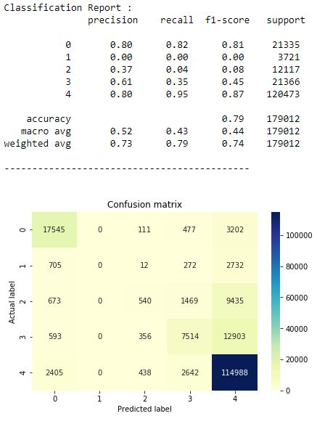
Figure 7: Evaluation Metric of Neural Network on Extra Tree Classifier Feature set.

Conclusion
In this paper, we present a comparative model approach on performance of five classifiers on five selected activities from the dataset. The classifier models show significant changes after application of precise data preprocessing and feature selection approach. Feed forward Neural Network has persistently detected all five activities with varying metric score in the five datasets of this research. The highest accuracy score achieved on these feature sets is 78%, provided that the feature engineering followed baseline approaches along with baseline classifiers. Hence, this research paper presents that for human activity recognition systems, data preprocessing and feature selection greatly affects the classification performance and consequently the AAL and AML structures on the basis of HAR. State-of-the-art classifier models have presented varying accuracy score on the basis of how well the dataset have been preprocessed for running machine learning model on the dataset.
The future work includes preparing customized neural network approach to classify the activities and on the basis of the model, we aim to produce a robust time-series model to handle adversarial attack.
The end goal of the research work is to inject adversarial attack on the model to confuse the network and identify the actual activity after the injection. To suggest more amicable work based on such data, this research team could be explored in variety of fields in health, administration and security issues where such dataset generation and model implementation will be useful for activity recognition.

References

- Q. Ni, A. B. García Hernando, and I. P. de la Cruz, “The Elderly’s Independent Living in Smart Homes: A Characterization of Activities and Sensing Infrastructure Survey to Facilitate Services Development.” Sensors. vol. 15, no. 5, pp. 11312–62, May 2015
- Banos, O., Garcia, R., Holgado-Terriza, J. A., Damas, M., Pomares, H., Rojas, I., Saez, A., & Villalonga, C. (2014). mHealthDroid: a novel framework for agile development of mobile health applications. In International Workshop on Ambient Assisted Living (pp. 91-98): Springer.
- K. Davis, E. Owusu, C. Regazzoni, L. Marcenaro, L. Feijs, and J. Hu,“Perception of human activities a means to support connectedness between the elderly and their caregivers,” in Proceedings of the 1st International Conference on Information and Communication Technologies for Ageing Well and e-Health. SCITEPRESS, 2015, pp. 194–199
- 5. A. Alberdi, A. Weakley, A. Goenaga, M. Schmitter-Edgecombe, and D. Cook. Automatic assessment of functional health decline in older adults based on smart home data. Journal of Biomedical Informatics, 18:119-130, 2018
- Y. Chen, L. Yu, K. Ota, M. Dong, "Robust activity recognition for aging society", IEEE J. Biomed. Health Inform., vol. 22, no. 6, pp. 1754-1764, Nov. 2018
- A. Alberdi, A. Weakley, A. Goenaga, M. Schmitter-Edgecombe, and D. Cook. Automatic assessment of functional health decline in older adults based on smart home data. Journal of Biomedical Informatics, 18:119-130, 2018
- N. A. Capela, E. D. Lemaire, and N. Baddour, “Feature selection for wearable smartphone-based human activity recognition with able bodied, elderly, and stroke patients,” PloS one, vol. 10, no. 4, p. e0124414, 2015.
- Chung, Seungeun et al. “Sensor Data Acquisition and Multimodal Sensor Fusion for Human Activity Recognition Using Deep Learning.” Sensors (Basel, Switzerland) vol. 19,7 1716. 10 Apr. 2019, doi:10.3390/s19071716.
- Cornacchia, M., Ozcan, K., Zheng, Y., & Velipasalar, S. (2017). A Survey on Activity Detection and Classification Using Wearable Sensors. IEEE Sensors Journal, 17, 386-403.
- S. Aminikhanghahi and D. Cook. Enhancing activity recognition using CPD-based activity segmentation. Pervasive and Mobile Computing, 53:75-89, 2019
- S. Aminikhanghahi, T. Wang, and D. Cook. Real-time change point detection with application to smart home time series data. IEEE Transactions on Knowledge and Data Engineering, to appear
- B. Chen, Z. Fan, and F. Cao, “Activity Recognition Based on Streaming Sensor Data for Assisted Living in Smart Homes,” in 2015 International Conference on Intelligent Environments, 2015, pp. 124–127.
- D. Cook, N. Krishnan, and P. Rashidi. Activity discovery and activity recognition: A new partnership. IEEE Transactions on Systems, Man, and Cybernetics, Part B, 43(3):820-828, 2013
- K. Robertson, C. Rosasco, K. Feuz, M. Schmitter-Edgecombe, and D. Cook, “Prompting technologies: A comparison of time-based and context-aware transition-based prompting.,” Technol. Health Care, vol. 23, no. 6,pp. 745–56, Jan. 2015.
- Nhan Duc Nguyen, Duong Trong Bui, Phuc Huu Truong, and Gu-Min Jeong, “Position-Based Feature Selection for Body Sensors regarding Daily Living Activity Recognition,” Journal of Sensors, vol. 2018, Article ID 9762098, 13 pages, 2018. https://doi.org/10.1155/2018/9762098.
- FangH,etal.Humanactivityrecognitionbasedonfeatureselectioninsmarthome using back-propagation algorithm. ISATransactions(2014)
[17] J.-L. Reyes-Ortiz, L. Oneto, A. Samà, X. Parra, and D. Anguita,“Transition-Aware Human Activity Recognition Using Smartphones,” Neurocomputing, vol. 171, pp. 754–767, Jan. 2016
[18] Chung, Seungeun et al. “Sensor Data Acquisition and Multimodal Sensor Fusion for Human Activity Recognition Using Deep Learning.” Sensors (Basel, Switzerland) vol. 19,7 1716. 10 Apr. 2019, doi:10.3390/s19071716
[19] Gu T, Wu Z, Tao X, Pung HK, Lu J. epSICAR: an emerging patterns based approach to sequential, interleaved and concurrent activity recognition. Proceedings of the IEEE International Conference on Pervasive Computing and Communications; 2009. pp. 1–9
[20] Nweke, Henry & Wah, Teh & al-garadi, Mohammed & Alo, Uzoma. (2018). Deep Learning Algorithms for Human Activity Recognition using Mobile and Wearable Sensor Networks: State of the Art and Research Challenges. Expert Systems with Applications. 105. 10.1016/j.eswa.2018.03.056
[21] A. Jordao, A. C. Nazare, J. Sena, W. R. Schwartz, "Human activity recognition based on wearable sensor data: A standardization of the state-of-the-art" in arXiv:1806.05226, 2018
[22] G. A. Oguntala et al., "SmartWall: Novel RFID-Enabled Ambient Human Activity Recognition Using Machine Learning for Unobtrusive Health Monitoring," in IEEE Access, vol. 7, pp. 68022-68033, 2019. doi: 10.1109/ACCESS.2019.2917125
[23] Pedregosa F, Varoquaux G, Gramfort A, Michel V, Thirion B, et al. (2011) Scikit-learn: Machine Learning in Python. J Mach Learn Res 12: 2825–2830
[24] Grabczewski, Krzysztof & Jankowski, Norbert. (2005). Feature selection with decision tree criterion. 6 pp.. 10.1109/ICHIS.2005.43.
[25] Kursa, Miron & Rudnicki, Witold. (2011). The All Relevant Feature Selection using Random Forest.
[26] Geurts, Pierre & Ernst, Damien & Wehenkel, Louis. (2006). Extremely Randomized Trees. Machine Learning. 63. 3-42. 10.1007/s10994-006-6226-1.
[27] Ali, Jehad & Khan, Rehanullah & Ahmad, Nasir & Maqsood, Imran. (2012). Random Forests and Decision Trees. International Journal of Computer Science Issues(IJCSI). 9.
[28] Raileanu, Laura & Stoffel, Kilian. (2004). Theoretical Comparison between the Gini Index and Information Gain Criteria. Annals of Mathematics and Artificial Intelligence. 41. 77-93. 10.1023/B:AMAI.0000018580.96245.c6.

